

**Course Title:** CSE110

**Section:** 06

**Semester:** Summer 22

**LAB-01**

**SUBMITTED TO**

Mahamudul Hasan

Department of Computer Science & Engineering

East-West University

***SUBMITTED BY***

**Name:** B M Shahria Alam

**Student ID:** 2021-3-60-016

**Date of submission:** 16 June 2022.

P1:

public class P1 {

public static void main(String[] args) {

System.out.println("Hello");

System.out.println("Donal Trump");

}

}

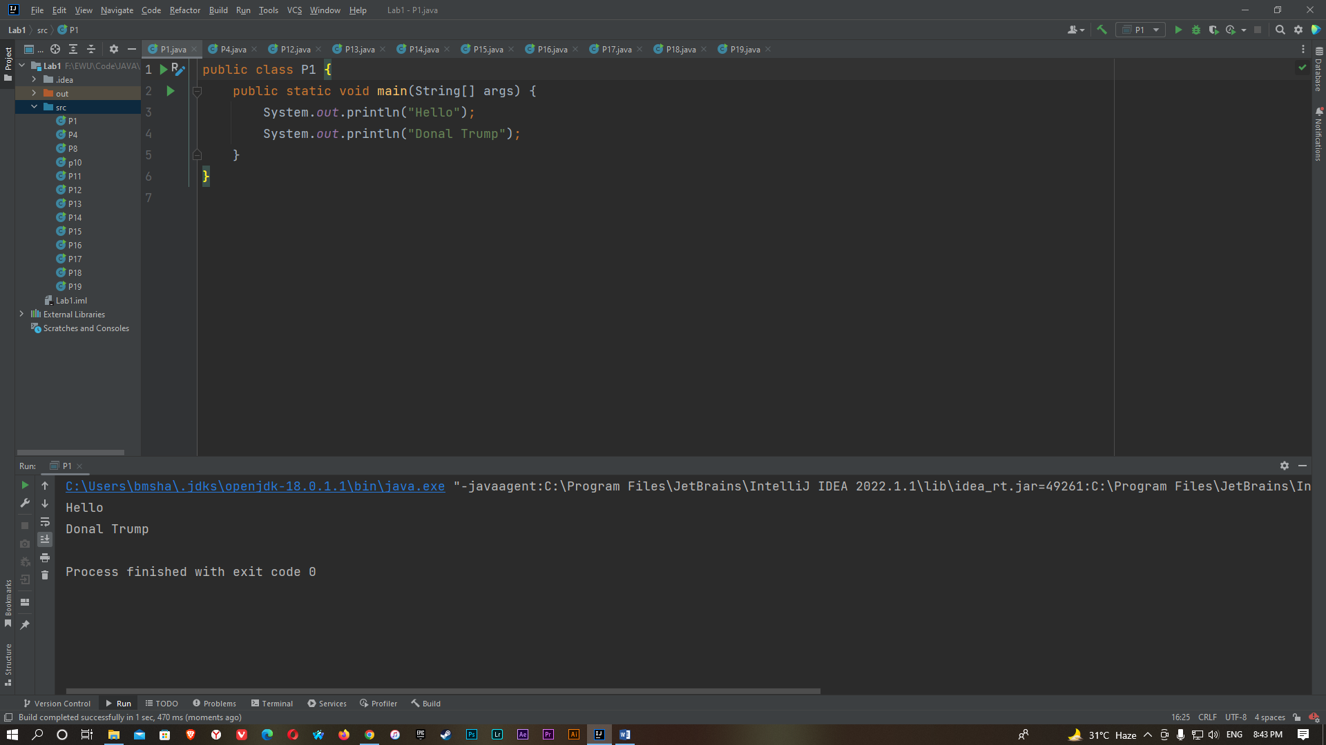

P2:

import java.util.Scanner;

class ProjectP2 {

public static void main(String[] args) {

Scanner input = new Scanner(System.in);

System.out.println("Enter the number:");

int x=input.nextInt();

if(x<25){

System.out.println("F");

}

else if(x>=25 && x<45){

System.out.println("E");

}

else if(x>=45 && x<50){

System.out.println("D");

}

else if(x>=50 && x<60){

System.out.println("C");

}

else if(x>=60 && x<80){

System.out.println("B");

}

else{

System.out.println("A");

}

}

}

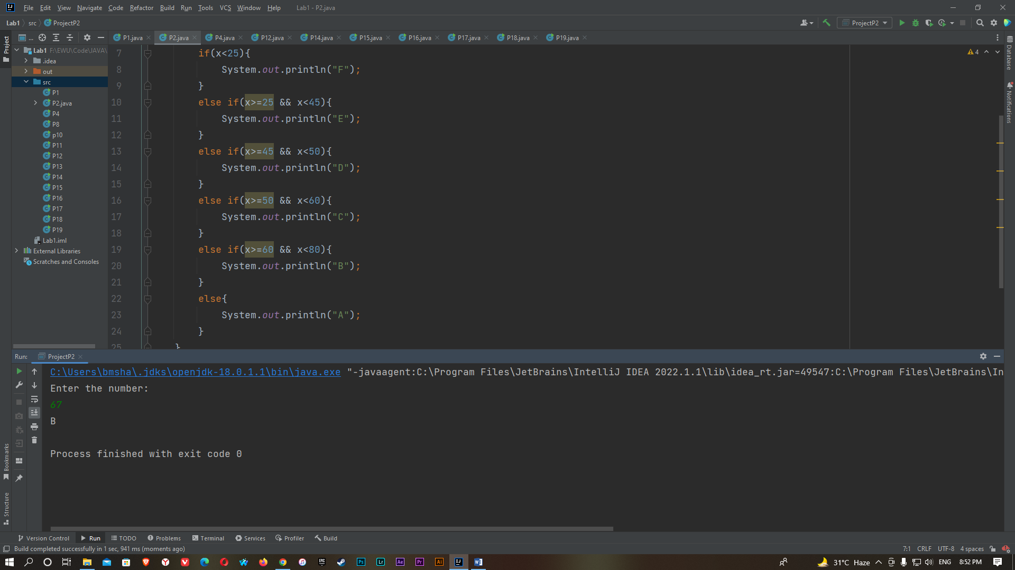

P3:

package project3;

import java.util.Scanner;

public class Project3 {

public static void main(String[] args) {

int i,gcd = 0;

Scanner input = new Scanner(System.in);

System.out.println("Enter the first number:");

int x1= input.nextInt();

System.out.println("Enter the first number:");

int x2= input.nextInt();

for( i=1 ; i<= x1 && i<=x2; i++)

{

if (x1%i ==0 && x2%i==0)

{

gcd= i;

}

}

System.out.println("gcd ("+x1 +","+x2 +")=" +gcd);

}

}

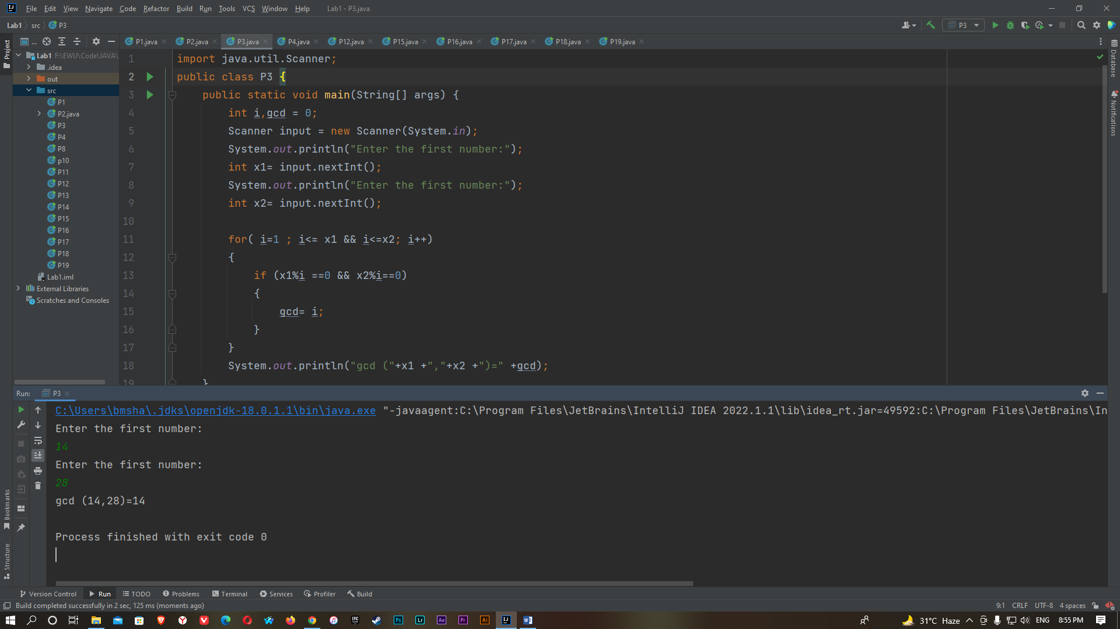

P4:

import java.util.Scanner;

public class P4

{

public static void main(String[] args)

{

Scanner input = new Scanner(System.in);

int i, a=0, j, x;

System.out.println("Enter the number:");

x = input.nextInt();

for (i = 2; i < x; i++)

{

if (x % i == 0)

{

a++;

}

}

if (a <= 1)

{

System.out.println(x);

}

else

{

for (i = x+1; i > 0; i++)

{

a = 0;

for (j = 1; j <= i; j++)

{

if (i%j == 0)

{

a++;

}

}

if (a == 2)

{

System.out.println(i);

break;

}

}

}

}

}

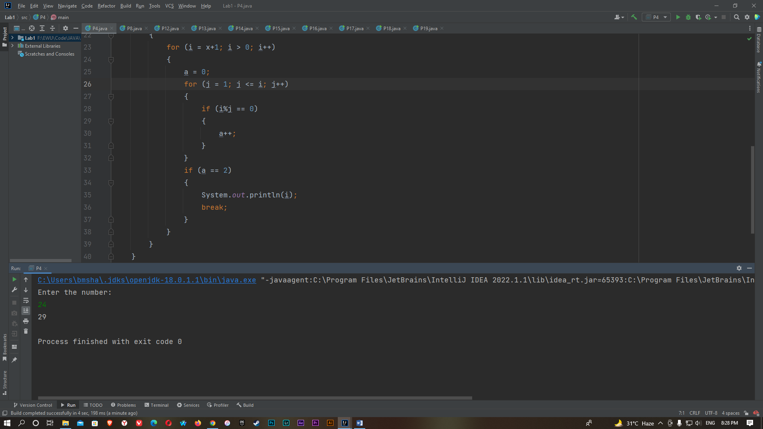

P5:

package project5;

import java.util.Scanner;

public class Project5 {

public static void main(String[] args) {

Scanner input = new Scanner(System.in);

int x,y,z;

System.out.println("Enter the first number:");

x= input.nextInt();

System.out.println("Enter the second number:");

y= input.nextInt();

z=x*y;

System.out.println(z);

}

}

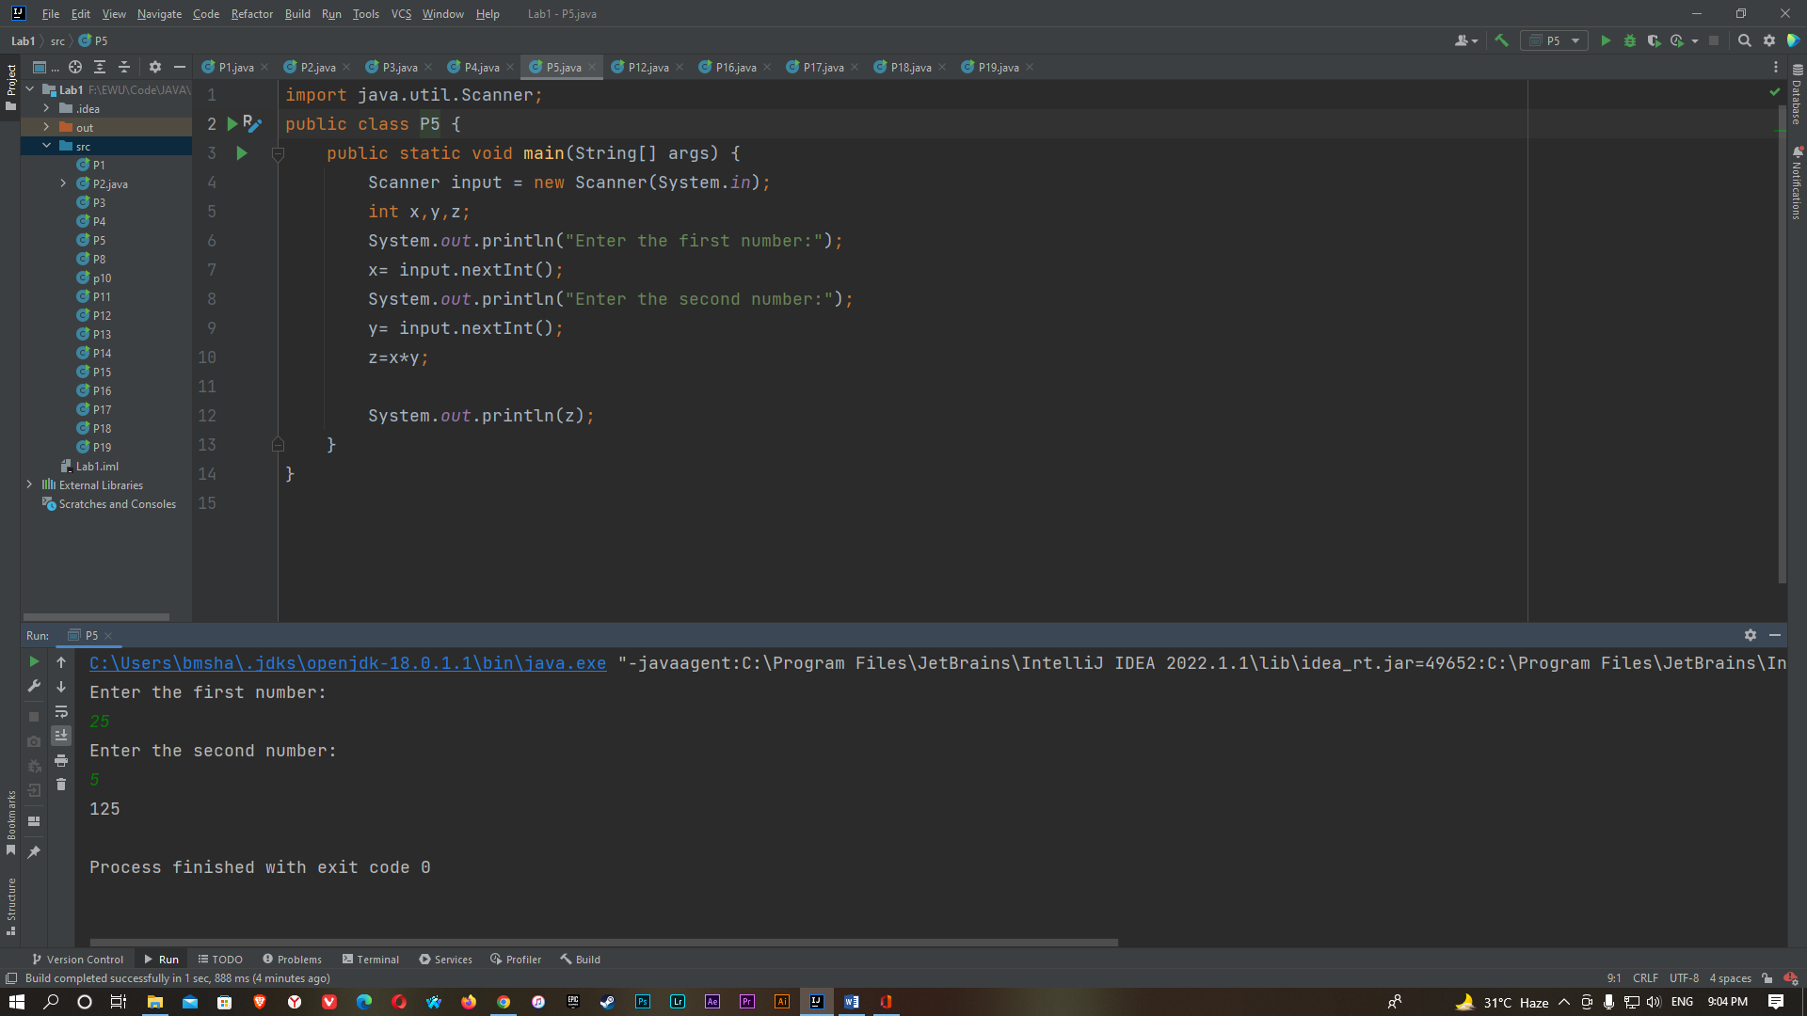

P6:

package p6;

import java.util.Scanner;

public class P6 {

public static void main(String[] args) {

Scanner input = new Scanner(System.in);

int x,y,a,b,c,d;

System.out.println("Enter the first number:");

x= input.nextInt();

System.out.println("Enter the second number:");

y= input.nextInt();

a=x+y;

b=x-y;

c=x*y;

d=x/y;

System.out.println(+x+"+"+y+"="+a);

System.out.println(+x+"-"+y+"="+b);

System.out.println(+x+"*"+y+"="+c);

System.out.println(+x+"/"+y+"="+d);

}

}

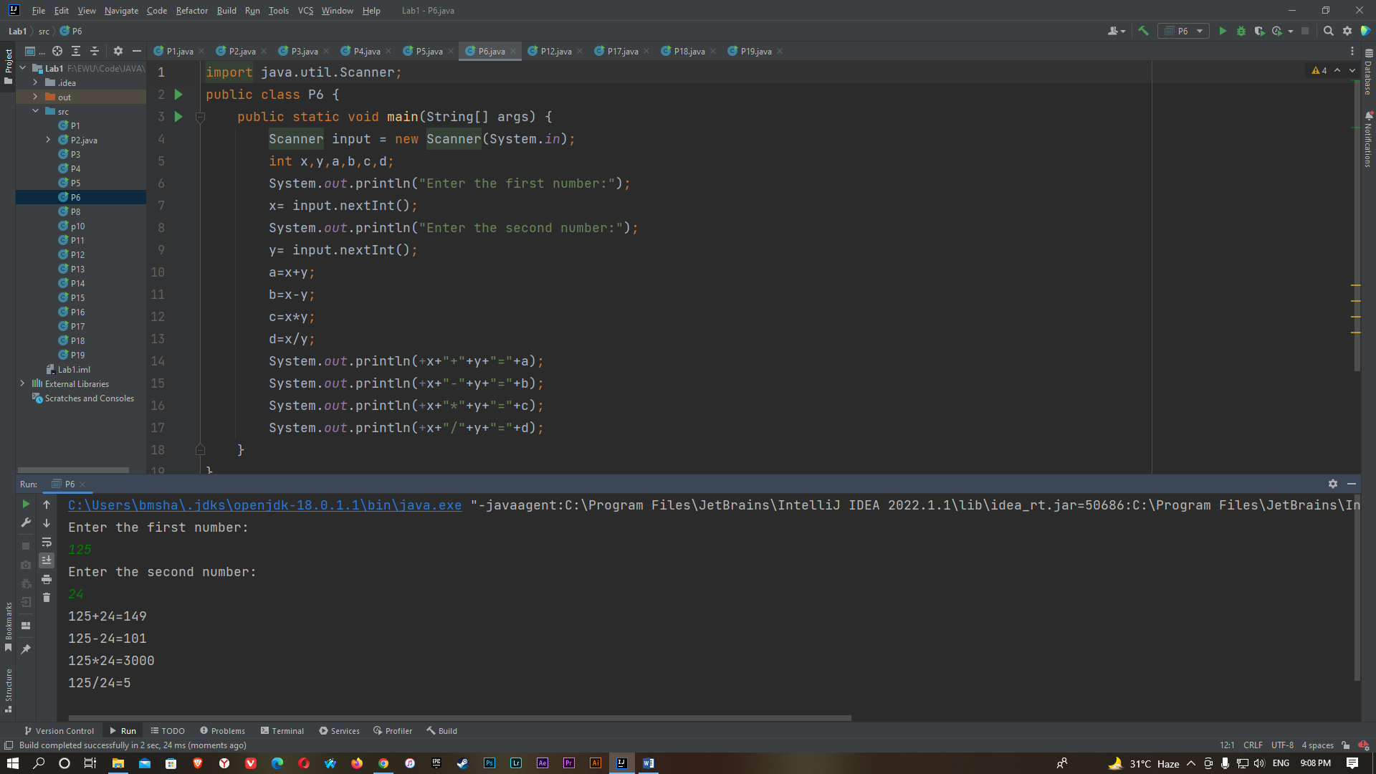

P7:

package p7;

import java.util.Scanner;

public class P7 {

public static void main(String[] args) {

Scanner input = new Scanner(System.in);

int x,i,y;

System.out.println("Enter the number:");

x= input.nextInt();

for(i=1; i<=10; i++)

{

y=x*i;

System.out.println(+x+"*"+i+"="+y);

}

}

}

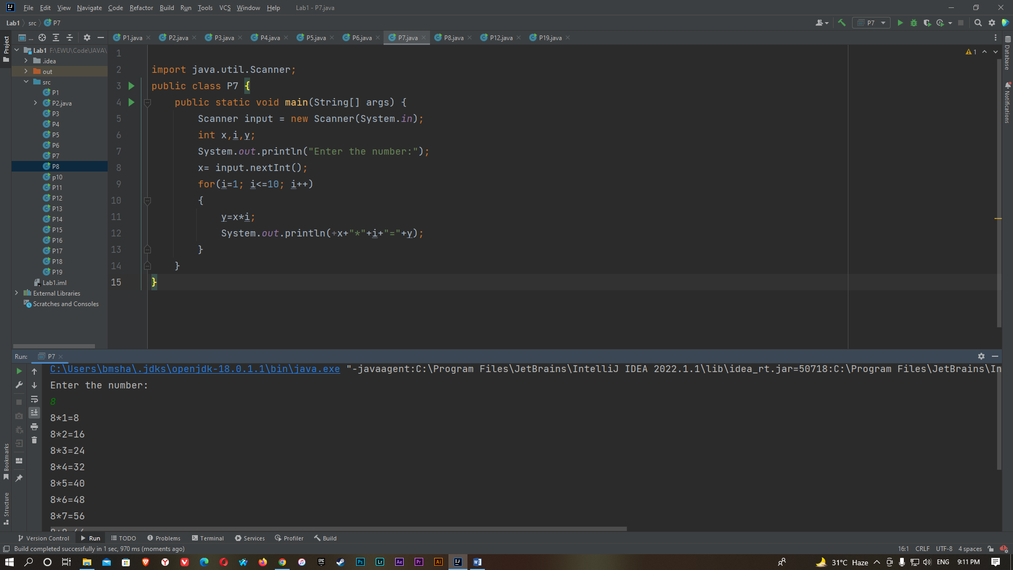

P8:

import java.util.Scanner;

public class P8 {

public static void main(String[] args) {

Scanner input= new Scanner (System.in);

int x,i,j,a,b=0;

System.out.println("Enter the number:");

x= input.nextInt();

for(i=2; i<=x; i++)

{

a=0;

for(j=2; j<i ; j++)

{

if((i%j)==0)

{

a++;

}

}

if(a<1)

{

b++;

}

}

System.out.println("Prime Number("+x+")= "+b);

for(i=2; i<=x; i++)

{

a=0;

for(j=2; j<i ; j++)

{

if((i%j)==0)

{

a++;

}

}

if(a<1)

{

b++;

System.out.print("\t"+i);

}

}

}

}

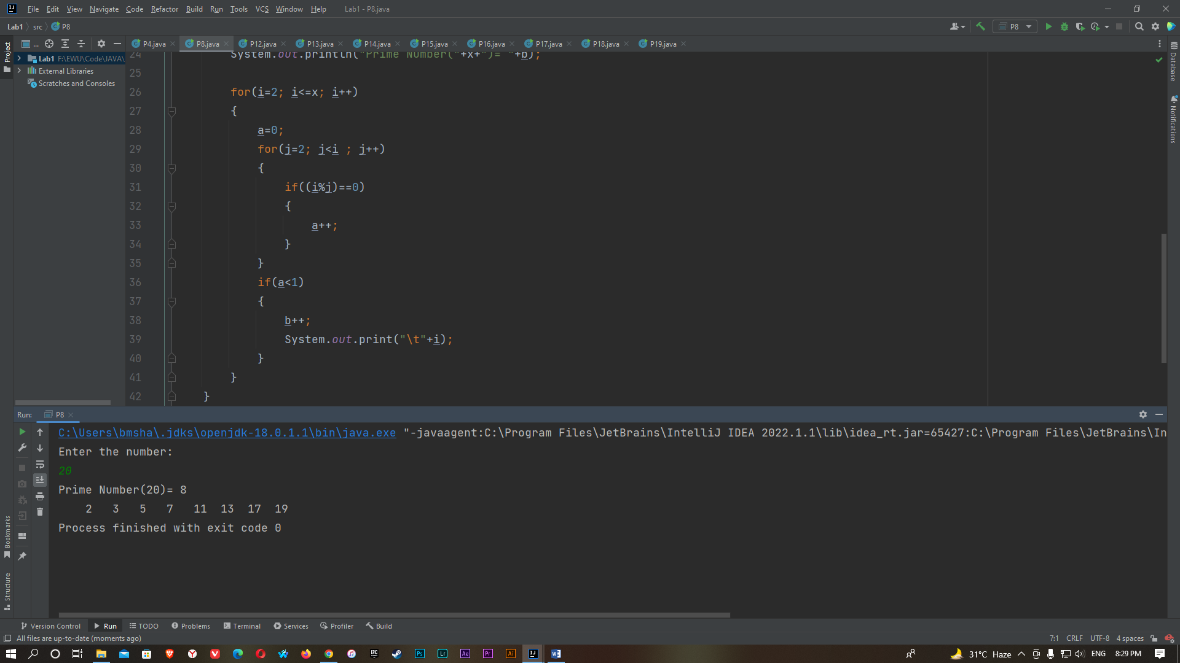

P9:

package p9;

public class P9 {

public static void main(String[] args) {

float x;

x= (float) (4.0*(1.0-(1.0/3)+(1.0/5)-(1.0/7)+(1.0/9)-(1.0/11)));

System.out.println(x);

}

}

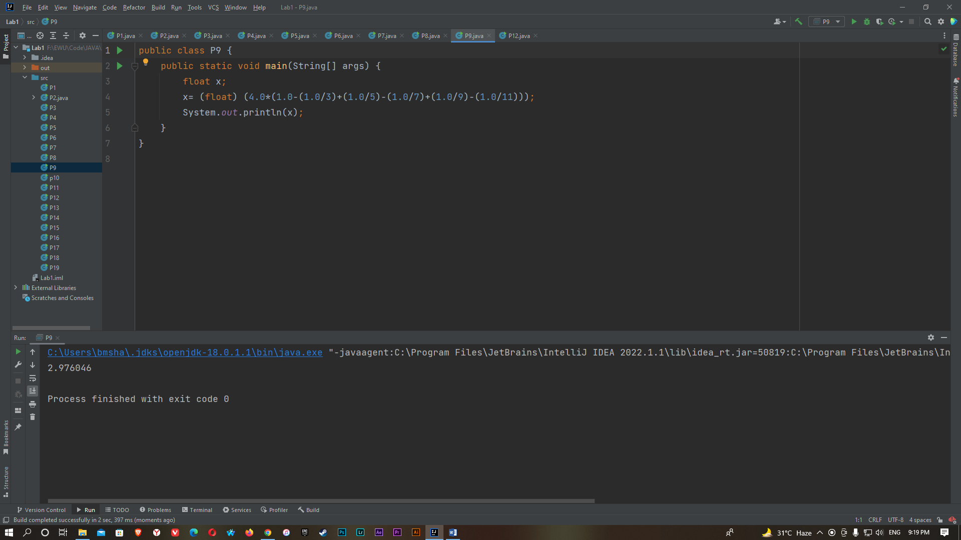

P10:

import java.util.Scanner;

public class p10 {

public static void main(String[] args) {

Scanner input= new Scanner (System.in);

float x,p,area;

System.out.println("Enter the radius:");

x=input.nextFloat();

area= (float) (x*x*3.1416);

p=(float)(2*3.1416*x);

System.out.println("Perimeter is: "+p);

System.out.println("Area is: "+area);

}

}

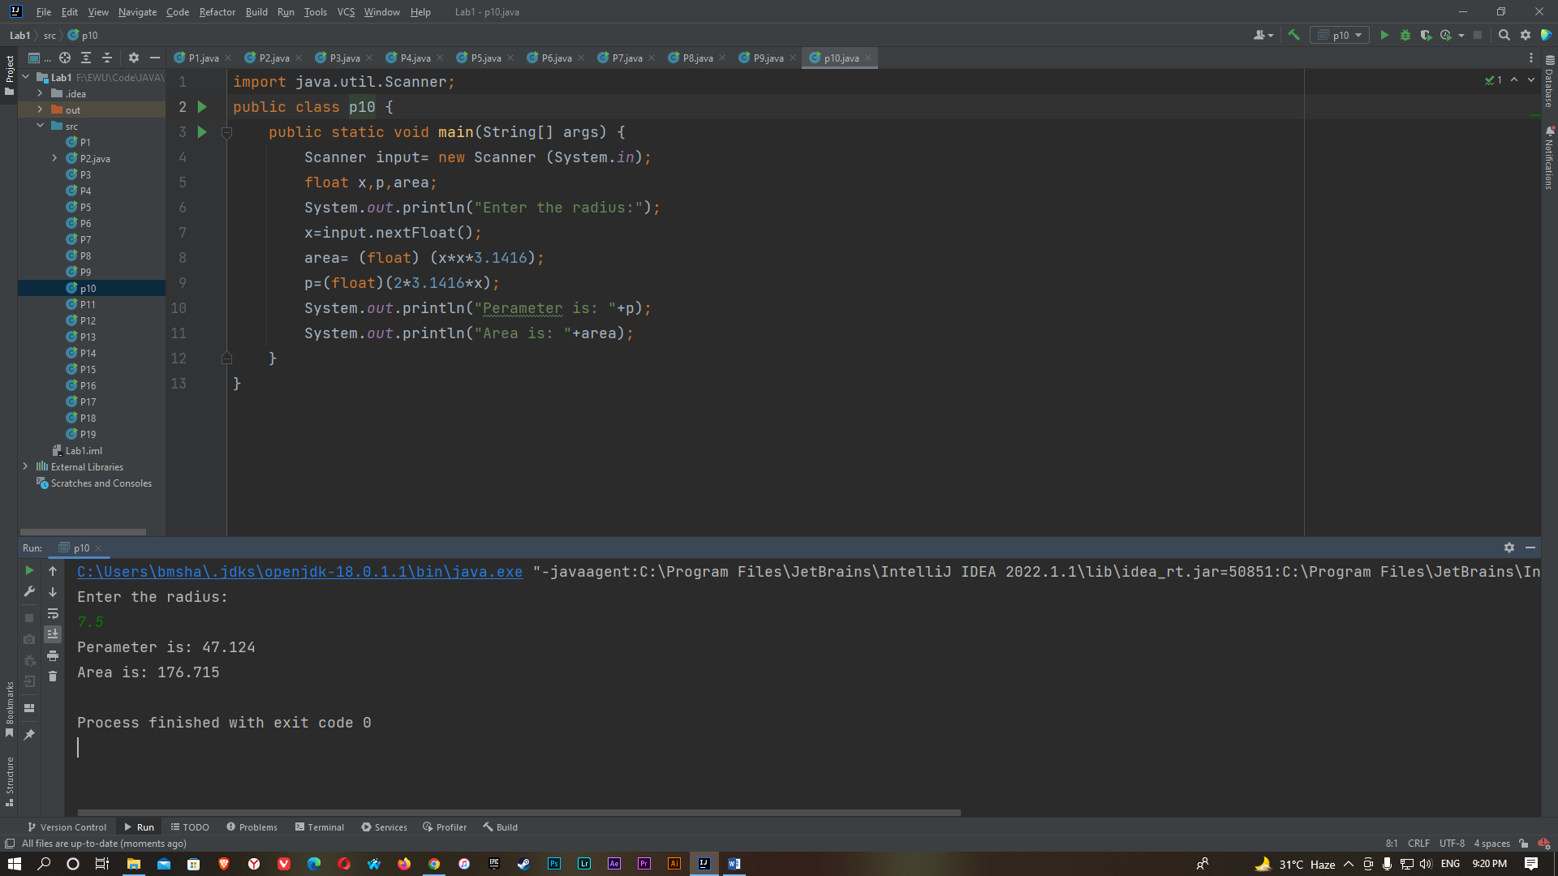

P11:

import java.util.Scanner;

public class P11 {

public static void main(String[] args) {

Scanner input= new Scanner(System.in);

int x,y,z;

float a;

System.out.println("Enter the 1st number:");

x= input.nextInt();

System.out.println("Enter the 2nd number:");

y= input.nextInt();

System.out.println("Enter the 3rd number:");

z= input.nextInt();

a=(float)(x+y+z)/3;

System.out.println("The avarage:"+a);

}

}

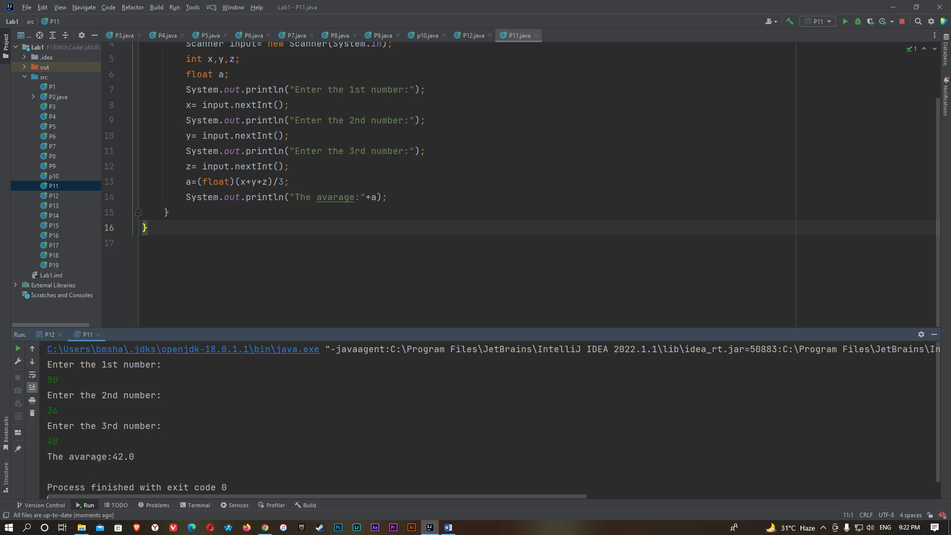

P12:

import java.util.Scanner;

public class P12 {

public static void main(String[] args) {

Scanner input= new Scanner(System.in);

float width, height,x,y;

System.out.println("Enter the width:");

width=input.nextFloat();

System.out.println("Enter the height:");

height=input.nextFloat();

x=(float)width*height;

y=(float)(2*(width+height));

System.out.println("Area is "+width+"*"+height+"= "+x);

System.out.println("Perimeter is 2*("+width+"+"+height+")= "+y);

}

}

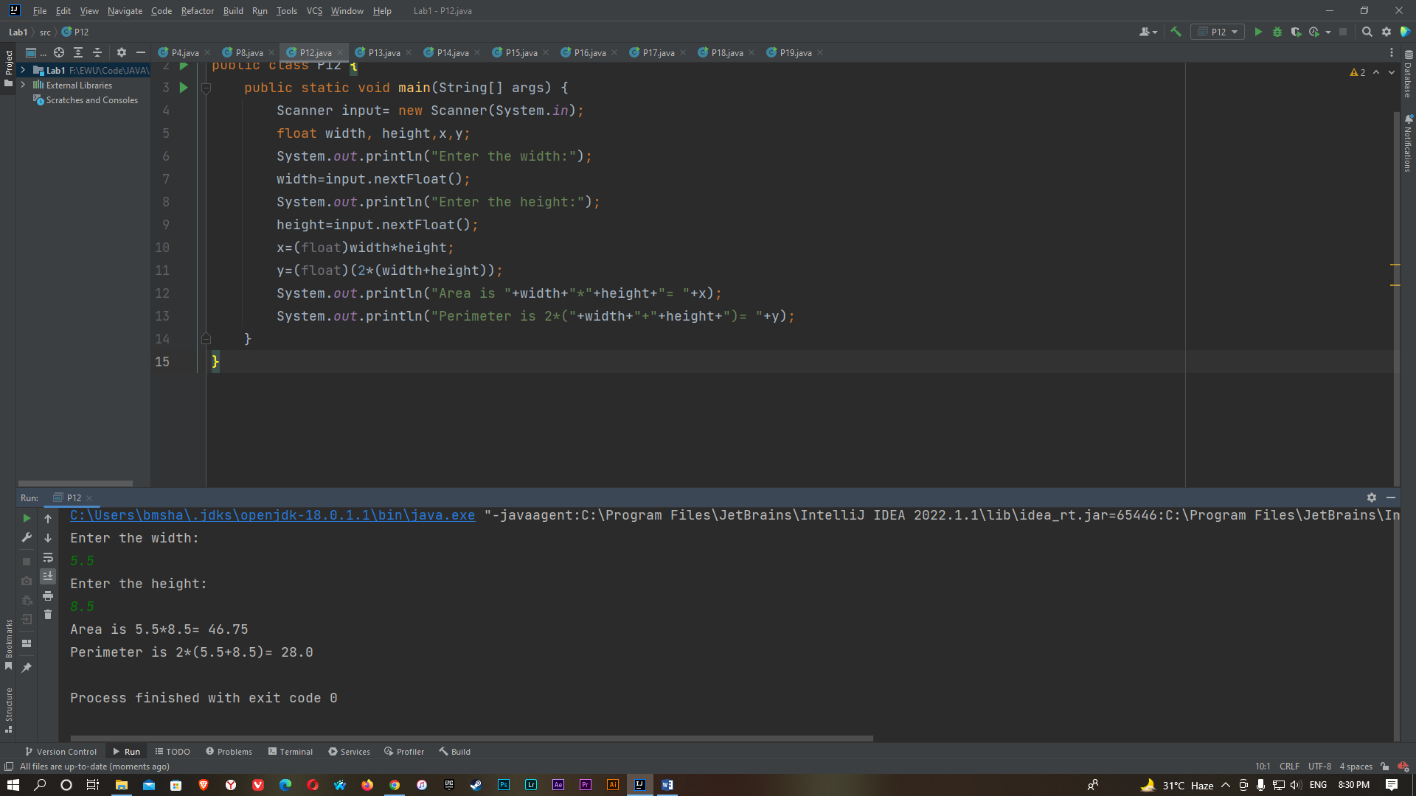

P13:

import java.util.Scanner;

public class P13 {

public static void main(String[] args) {

Scanner input= new Scanner (System.in);

int x,y;

System.out.println("Enter the first number:");

x=input.nextInt();

System.out.println("Enter the second number:");

y=input.nextInt();

x=x+y;

y=x-y;

x=x-y;

System.out.println("After swap \nx= "+x+ "\ny= "+y);

}

}

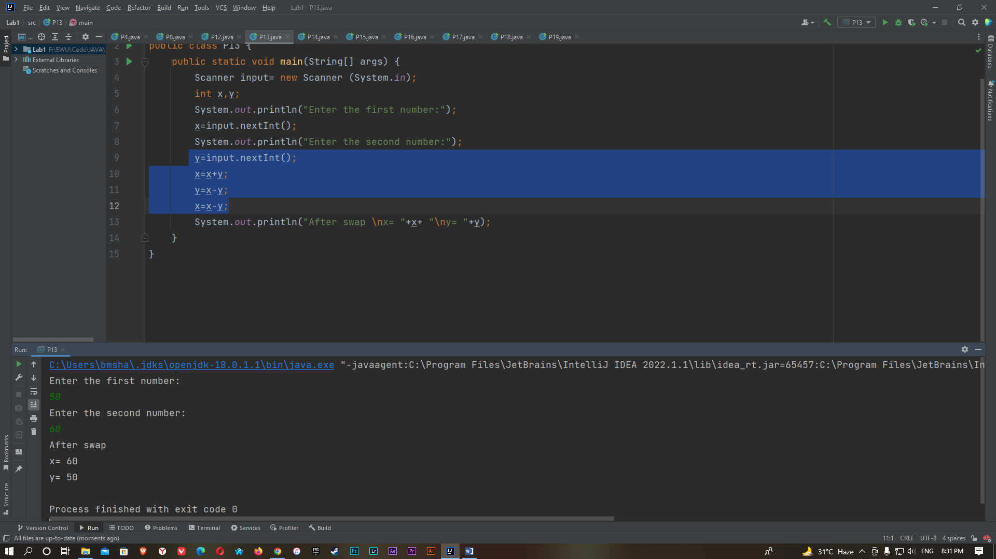

P14:

import java.util.Scanner;

public class P14 {

public static void main(String[] args) {

Scanner input = new Scanner(System.in);

int x,y;

System.out.println("Enter the first number:");

x=input.nextInt();

System.out.println("Enter the first number:");

y=input.nextInt();

if(x==y)

{

System.out.println(+x+"="+y);

}

if(x!=y)

{

System.out.println(+x+"!="+y);

}

if(x<y)

{

System.out.println(+x+"<"+y);

}

if(x>y)

{

System.out.println(+x+">"+y);

}

if(x!=y)

{

if (x >= y) {

System.out.println(+x + ">=" + y);

}

if (x <= y) {

System.out.println(+x + "<=" + y);

}

}

}

}

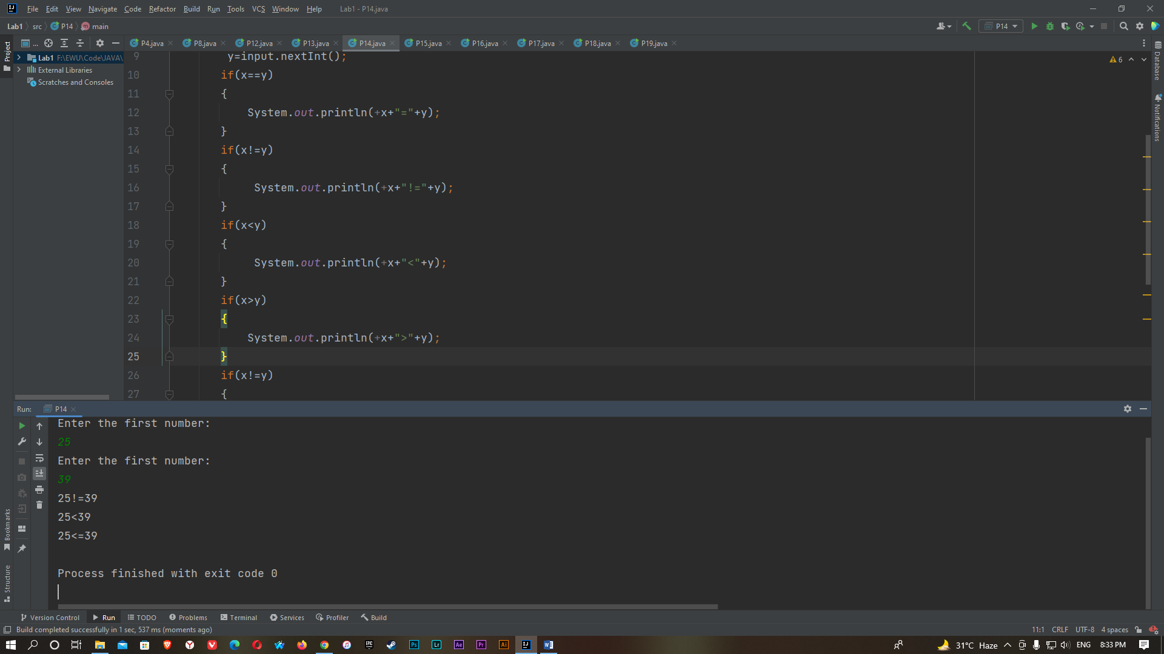

P15:

import java.util.Scanner;

public class P15 {

public static void main(String[] args) {

Scanner input = new Scanner(System.in);

int x,y,a=0;

System.out.println("Enter the number:");

x=input.nextInt();

while(x>0)

{

y=x%10;

a=a+y;

x=x/10;

}

System.out.println("The sum of the digits is: "+a);

}

}

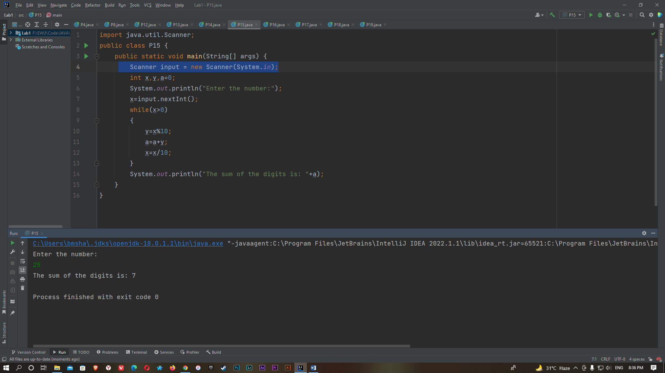

P16:

import java.util.Scanner;

public class P16 {

public static void main(String[] args) {

Scanner input = new Scanner(System.in);

int i;

System.out.println("The odd numbers from 1 to 99 are:");

for(i=1; i<100; i++)

{

if(i%2!=0)

{

System.out.println(i);

}

}

}

}

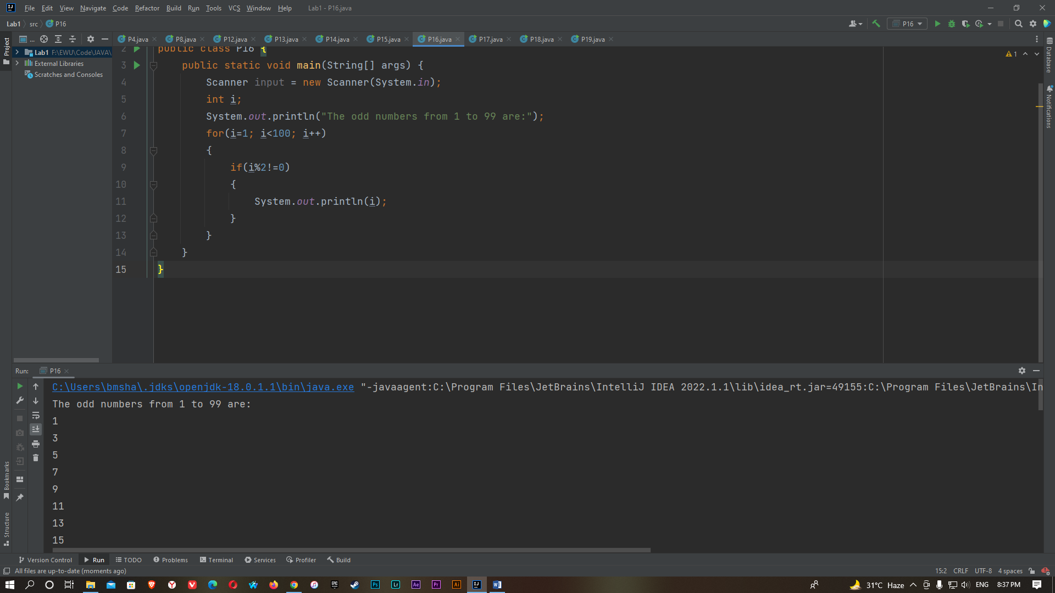

P17:

import java.util.Scanner;

public class P17 {

public static void main(String[] args) {

Scanner input=new Scanner(System.in);

int x,a=0,b;

System.out.println("Enter the number:");

x=input.nextInt();

while(x!=0)

{

b=x%10;

a=a*10+b;

x=x/10;

}

System.out.println("Reversed number:"+a);

}

}

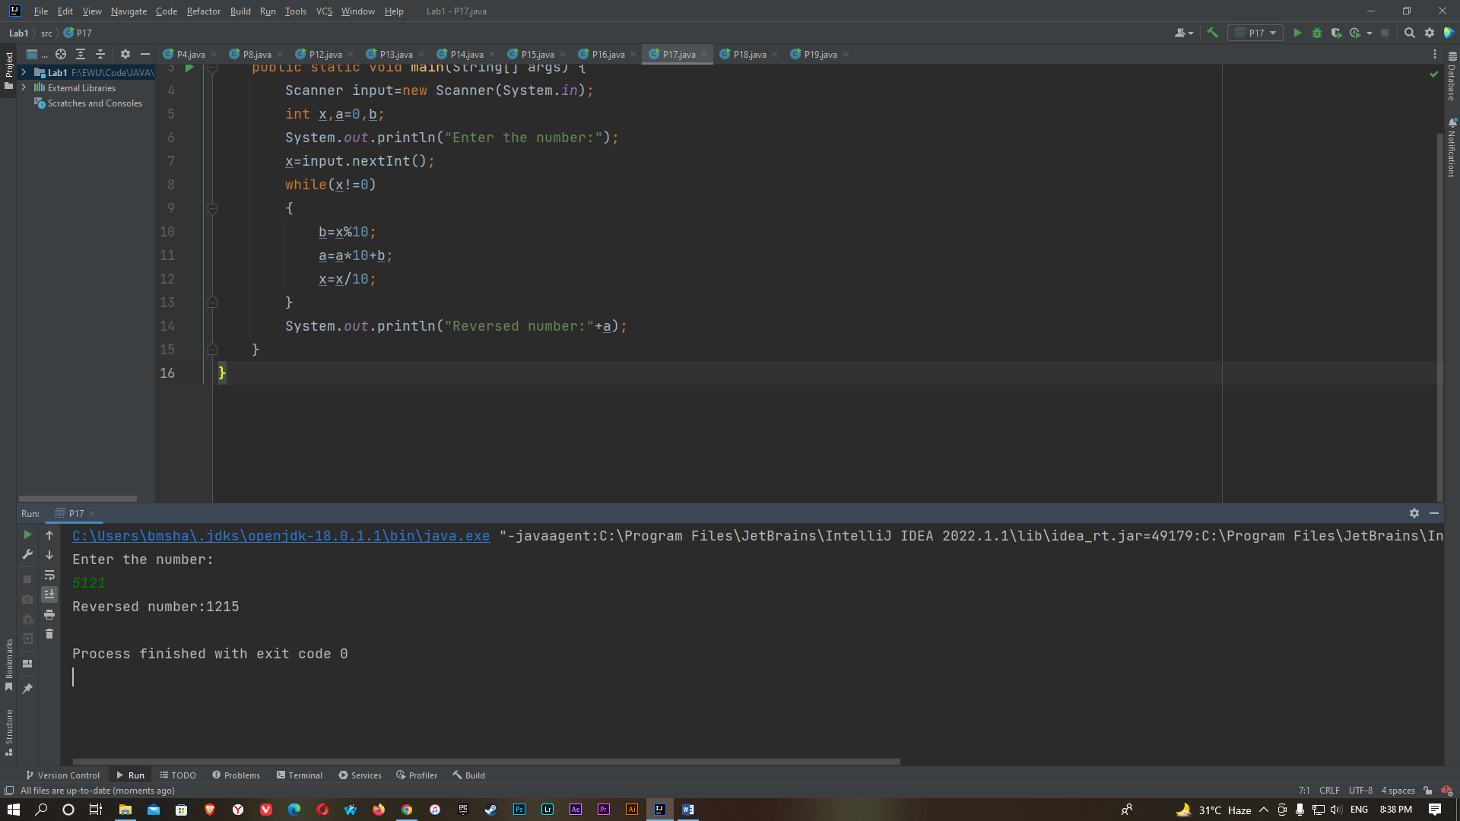

P18:

import java.util.Scanner;

public class P18 {

public static void main(String[] args) {

Scanner input = new Scanner(System.in);

int a,b,c,d;

System.out.println("Enter the 1st number:");

a=input.nextInt();

System.out.println("Enter the 2nd number:");

b=input.nextInt();

System.out.println("Enter the 3rd number:");

c=input.nextInt();

d=a+b;

if(d==c)

{

System.out.println("The result is: True");

}

if(d!=c)

{

System.out.println("The result is: False");

}

}

}

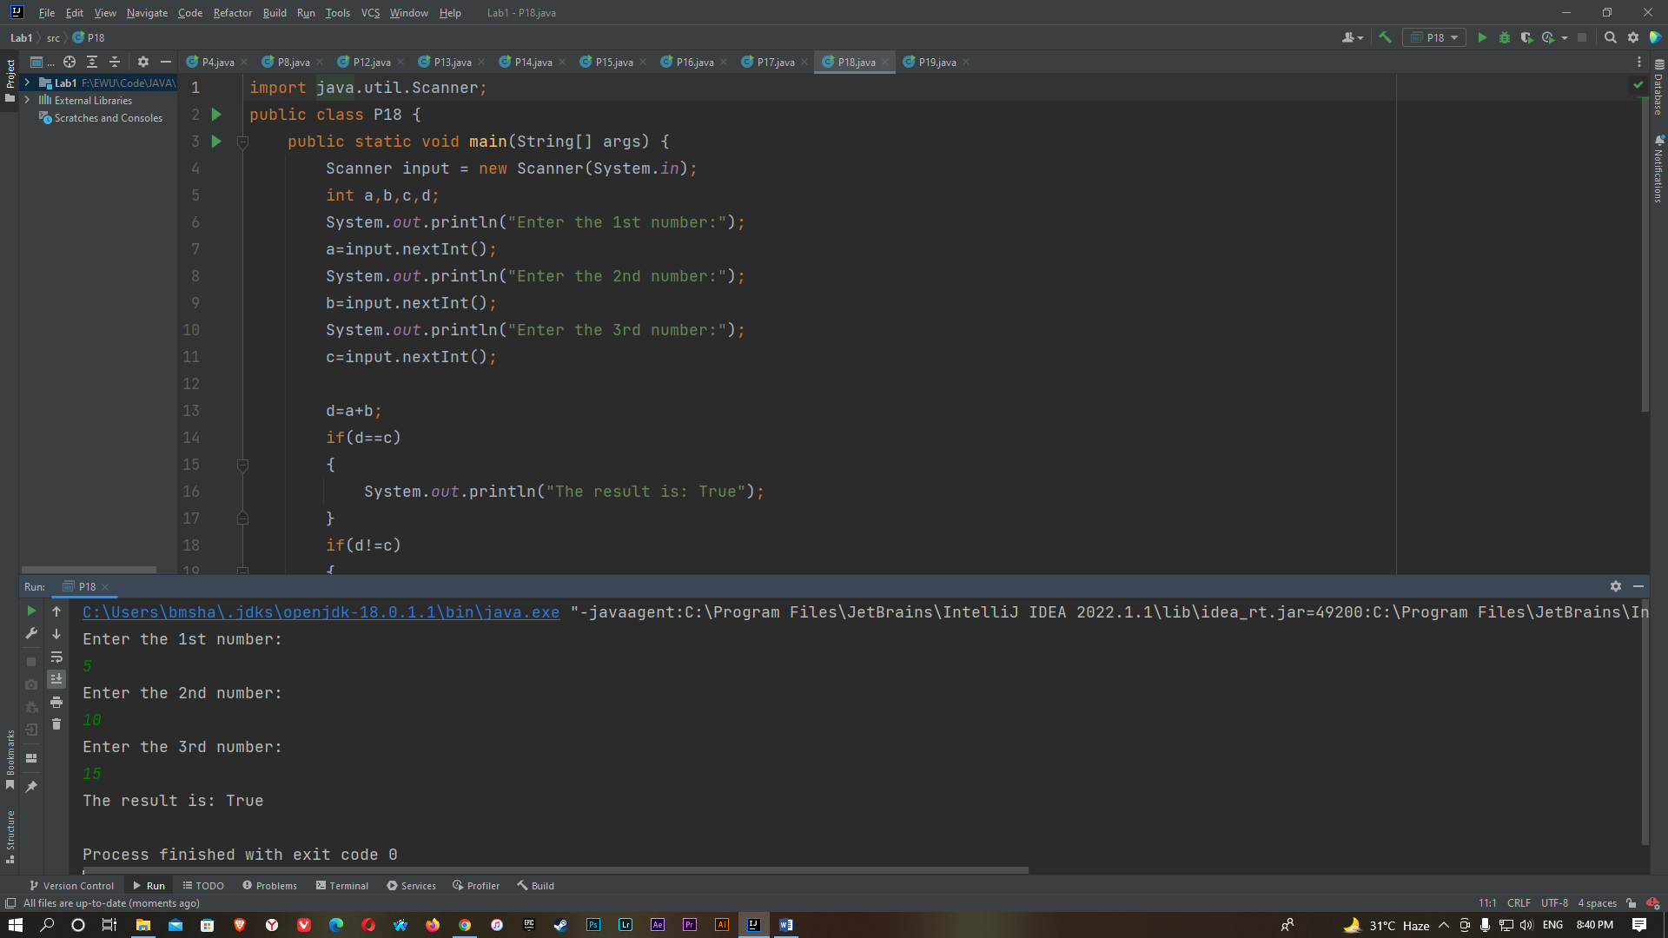

P19:

import java.util.Scanner;

public class P19

{

public static void main(String[] args)

{

int i,a,j,b=0,c=0;

for(i=2; i>0; i++)

{

a=0;

for(j=2; j<i ; j++)

{

if((i%j)==0)

{

a++;

}

}

if(a<1)

{

b=b+i;

c++;

}

if(c==100)

{

System.out.println("Sum of the first 100 prime numbers is: "+b);

break;

}

}

}

}

